

Training Management and Development

Etisalat Limited
Yaqoob Alshamsi
Jamal Albraiki
Ahmed Al Ali
Dr. Christina Koutra
November 30th 2018

Table of Contents
Abstract 1
Executive Summary 2
Managing Training Needs 3
Job Requirement Analysis 4
Organizational Level Analysis 4
Job description 5
Job identification 5
Job summary 5
Relationships 5
Responsibilities 6
Authority 6
Standards of performance 6
Working conditions and environment 6
Job specifications 6
Hiring process 6
Training Programs 7
Reaction and course of action 8
Level of learning and confidence evaluation 8
Impact on behavior 8
Outcome 8
Lecturing 9
On-the-job-training 9
Instructional job training 9
Videoconferencing 9
Audiovisuals 9
Emerging technologies and trends 9
Performance/Operational Level Analysis 10
Human Resource/ Person Analysis 10
Budget Allocation 12
Internal Budget Allocation 12
Special Budget Allocation: 12
References 14

Etisalat Limited

Abstract
Etisalat Limited is a company that specializes in providing telecommunication services in the United Arab Emirates. Clients come to us for assistance in the mobile phones and other allied devices. We also deal with the installation of data cables and fiber optics in the Middle East and Africa. Consultancy regarding mobile phones and other communication is an area that we put emphasis on because a satisfied customer will in most cases feel comfortable shopping where he or she felt at home. As part of our full service, we offer Training to our potential employees before they are fully incorporated into our company. This paper is meant to provide an insight into how training is facilitated in Etisalat Limited as well as services offered there. How customers interact with the company is another key area that will be looked at so as to examine how employees facilitate hospitality to people. Having a training model to act as a blueprint in the realization of effective will be key in ensuring that the right procedure is undertaking when facilitating training.

Executive Summary
Training has become an integral part of most companies’ structures due to the specific needs required for individual companies. As such the need has risen for the prior training of potential employees ready to be incorporated into a company’s payroll. This is important in helping the potential employee better familiarize him or her with what the company expects from them. In learning institutions such as universities, the kind of training being offered is largely generalized and not specific to all company which means that an individual might get a difficult time being incorporated into a given company for employment (Nyokabi, 2014). It becomes vital for companies to offer the initial training for newbies before gaining acceptance as formal employees at the company at hand.
Training has become something strategic in making sure certain guidelines are followed when one is working for the company. Training will ensure that there are order and continuity with the stated missions, goals and milestones the company wants to reach. While the company offers training to potential employees, new skills are learned by the latter and are only unique to the company at hand which means that the individual will be tuned to only what services the company expects to realize. The incorporation of training programs and new technology will help transform the company’s ability to offer adequate training to its employees. The organization’s operational level and human resource will be key in ensuring the smooth running of services within the company. In addition to that, any kind of training will require a touch from these two elements to fully live to its intended purpose.
YOU STATE WHAT AND HOW IS TO BE DISCUSSED AND WHY
Meaning, what the report will be on? What training will be used, what methods? Who will train? Why? Details about the company should follow below.. present Etisalat..
What will be discussed in the main body…
Present Etisalat in a paragraph, nature of the company, small details about it…
Second paragraph should be specific about the trainining.

Managing Training Needs
Specific jobs call for specific requirements and very unique forms of training to suit them for smooth running of operations. Before any training, it is important to have an actual analysis of the need for that training. The manager also needs to have full knowledge of why it is important to offer training to potential employees before being fully incorporated into the organization.
Below is an illustration of a training model used in facilitating competency;
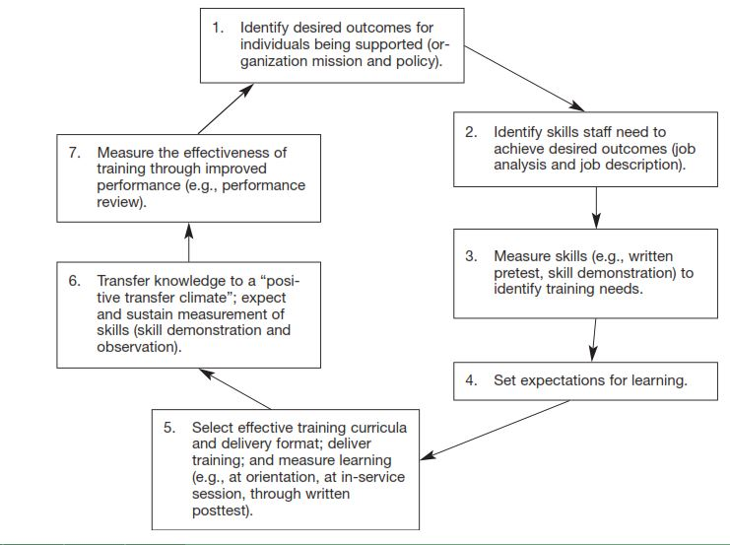
Figure 1: Training model for attaining competency
EXPLAIN THE TABLE
Evaluation and feedback from training are very vital in the decision-making process. Results attained from training are used as input in determining whether all goals have been met by the employees (Zahra, Iram and Naeem, 2014). These inputs are such as the trainee’s and trainer’s feedback as well as the learning behavior of the trainee.
These needs analysis are as follow; Job requirement analysis, organizational level analysis, operational/performance level analysis and Human resource/Person Analysis

Job Requirement Analysis
What the company expects from potential employees is clearly stated and examined in the job description. When a certain employee is found to be missing out in some of the requirements stated, he/she is made a candidate for a training program that is fully covered by the organization.

Organizational Level Analysis
Organizations and companies want to remain consistent with what they offer, whether a product or a service. The product or service has to remain the same regardless of the influx of new employees into the company. If a company was to have a product or service that is not in the same standard as the rest, it would mean that the consumer or customer would not feel satisfied and that would mean losses for the company at hand.
The empowerment of youths is a mission for our company and would like to see many young talents put to work. To enforce this having a larger young generation in the workplace and training will be one of our aims. The young generation will be the future of the company, therefore, training them will offer an opportunity for them to serve the company much longer rather than employing and training the already aged. This organizational level will help in changing jobs to provide a window of opportunity through which such young employees will be able to realize their full potential that will, in the long run, benefit the company. Through this model, the company will be able to attract the young generation as well as retain an adequate workforce.
Employees have different competencies and are therefore placed on different job titles so as to accomplish varied tasks. From this, an organization needs to have a workflow that clearly shows how essential tasks are to be carried out in the organization (Engetou, 2017). The identification of competencies is an important aspect that helps in making a company have some sort of organization.
There are a number of issues that need to be considered when one wants to offer superb training and easy time finding competent employees in an organization. These issues are as follows;

Job description
It is important to have a clear definition of what is expected from the potential employee as well as what the company plans to achieve. When describing a job, one must put emphasis on the duties, working conditions, reporting responsibilities and the general responsibilities of the job being offered. Describing a job makes it easier for Human Resource (HR) planning which means that the HRM will not have difficulties in knowing what the requirement for a specific job is as well as the number of staffs required for various positions.
It will be easier for the HRM to make selections and recruitments on potential employees who have fully satisfied the requirement. Simply, sorting is made easier by disregarding those not meeting the required standards for the job. Labor relations are enhanced since the job descriptions act as the basis in which wage bargaining and classification of a job are done. It is easier for the HRM to make a new recommendation on the new class of potential employees in terms of the form of training they are to receive. That can be made possible by making a comparison between requirement of those employees already working with the company and potential employees eyeing positions within the company (Hazra et al., 2017). In all these, training and career development will have been enhanced to becoming more efficient.
There is no specific format by the labor laws on how or what should appear in a job description. However, there are general guidelines that can be followed which can be as follows;
Job identification: In this, we can have the Title of the Job, Status and Code of the Job, Date, Job location, Salary amount, Name of the supervisor, Approved by.
Job summary: What the job entails and its entire nature is described here while only emphasizing on the jobs major functions and perceived activities.
Relationships: Partners in the workplace are listed here in form of the ones expected to frequently interact with. The people one should report to, supervisors and other external contacts.
Responsibilities: This will entail duties of the job described. The HRM ought to draft a detailed list having the actual job responsibilities so as to make it easier to come up with training requirements for potential employees so that all appraisals can be defined while justifying the qualification required (Nassazi, 2013).
Authority: This states the position of the potential employee in terms of who can be supervised and the ability to make decisions within the company.
Standards of performance: This part defines the standards expected by the company from the potential employee. It states clearly which standard is expected as well as performance that is expectable.
Working conditions and environment: This will state all conditions within the company such as the noise level, hazards presents, temperature, working hours, travel time, the level of privacy and how frequent one will be interrupted while in the workplace.
Job specifications: The level of skills to be expected by the company is stated here which include the experience, educational qualifications, professional requirements, communication skills and other licenses and certificates from regulatory bodies. The physical and mental requirements are also included here to meet the standards of the company at hand.

Hiring process
Organizations will want to hire people with the right attitude and skills that will ensure a positive continuity in the efficient running of operations within the organization. The human resource is greatly inter-twinned with the realization of quality services and products. Having a quality human resource will mean the key a positive productivity in the company’s undertakings.
Recruitment is done so as to help find many candidates for the position at reduced costs. It will also aid in increasing the rate of success in selecting potential employees simply by eliminating applications by unqualified persons. Recruitment is vital in fulfilling the legal obligations regarding the workforce in the wider world (Barmao, 2009). It also creates a state of credibility and openness regarding the demographic composition of the population and thus not feel left out of a job opportunity. Candidates with job requirements that are suitable for the organization are encouraged to join the company’s environment that is unique to other organizations.
Selection pertains to the choosing of persons with relevant qualification for a certain job listing. This is done after all ‘on-paper’ requirements have been fulfilled as requested by the company with the job opening.
Below is a depiction of the selection process;
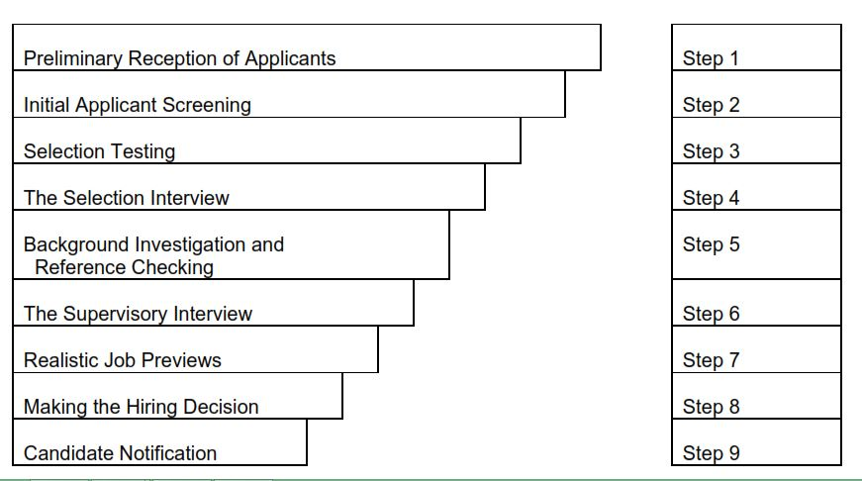
Figure 2: Selection Process

Training Programs
Training should be offered to the already selected candidates with qualifications in the fields of education, experience, and skills as a whole. Companies must determine competence that is necessary for those employees operating in areas that directly affect the quality of service or product. Making sure that the trainees are aware of the importance of the training they are undertaking is an emphasis a company should make so as to create a sense of commitment from the trainees. For employees to better familiarize themselves with new changes, an organization ought to offer training to them after orientation and during intervals when a new policy or tasks has been put in place. This helps employees keep in check with the ever-changing dynamics of any given organization or company.
Employee orientation is done to help new employees better have some background information about a given company as well as its stated values and achievements. Missions and visions for the organization are let known to the new employee so as to offer a sense of direction for what the company at hand means to achieve in the near future. While orienting new employees, the HR means to inculcate all prevailing standards, values, behaviors and attitudes which the organization means to achieve. This also helps the new employee to easily blend into the new workplace
New employees get to perform tasks under supervisions of their superiors or existing employees who help them in familiarizing with the new workplace. Regardless of how qualified an individual can be in terms of educational background, he/she hardly gets to a perfect new work that is as another place (Hazra et al., 2017). New realities have to be learned from experience since one workplace greatly differs from the other and the same technique or skills used to solve problems in a previous one could prove problematic in a new workplace.
When training has been carried out on employees, the evaluation of their feedback is done to get paint a picture of the impact of the training. This ultimately helps in determining the next course of action.
The impact of such results is measure in prerequisite manner as shown:
Reaction and course of action: It basically refers to how individuals reacted from the experience had in the training process. Employees respond differently when in a learning expedition and would have different results while in the workplace.
Level of learning and confidence evaluation: how much was gained from the experience in training is measured both at the beginning and at the end of the training. Some employees might have increased greatly in knowledge while some could have changed slightly.
Impact on behavior: This is how individual would behave following the aftermath of the training. Some employees might just act normal while some might improve positively compared to how they used to operate before.
Outcome: Questions need to be answered after the employees received their training. These questions are such as: Did costumers file any complaints regarding our services after the training? Has there been a decline in the number of customers and visitors at our company? Simply, if the training did not produce any measurable performance then we can just say that the training program did not live to its obligations and did not achieve its goals.
There are a number of techniques that can be used to offer training to new employees. They include some of the following;
Lecturing: This method can be used to convey information about an institution. It is vital when the number of employees is many and difficult to use other methods.
On-the-job-training: It is one of the most common methods of training whereby the new employee is being supervised while carrying out practical tasks for the organization. The supervisor helps where possible and studies what the new employee does while performing the actual tasks (Barmao, 2009).
Instructional job training: Basic tasks for specific job functions are listed down while noting major tasks so as to help in the provision of an orderly training.
Videoconferencing: When there are several sites from the same parent company, this method is ideal as it will broadcast the same message to all satellite areas where the new employees have been posted. It serves a larger audience and scope instead of having different pieces of training for the same company.
Audiovisuals: This is a new technology that is vital in showing real-time activities and operations being carried out by a company. New employees can get to see first-hand on how tasks are being carried out by veteran employees. A good example is that of the underwater robotic submarine vessel that records real-time videos while checking or repairing oil rigs in the ocean. Operators use joysticks to operate on the robotic submarine while clearing rocks in the deep sea. Employees can easily learn a great deal on how to carry out such operations in the future.

Emerging technologies and trends
New technologies are discovered as time goes by means that organizations need to embrace these new technologies for better and cost-effective benefits to them. To keep up pace with these new technologies, organizations need to keep providing new training to employees so as to function efficiently without the risk of ever slowing down in terms of productivity. Linking up with laboratory technologies can be beneficial to the company since its employees receive training on any new trend while paying for its employee's expenses. From this, employees can remain viable and loyal to the organization which in truth is a win-win situation for both parties (Niazi, 2011).
These educational programs mean that an individual's skill remains valid for the job position they are in. Employees reap benefits by having their knowledge and skills refreshed by the laboratory technology at hand. However, new skills and knowledge are learned by employees regarding the job position a single individual is in. Employees reap benefits in that they gain knowledge and skills regarding a potential growth in their professional development.

Performance/Operational Level Analysis
This is the demonstrable element in a company. Training is assessed by how tasks are executed by individuals against the standards set for operations by the company. These are practical day-to-day activities that a company carries out in order to ensure that operations are running smoothly as required (Nassazi, 2013). Conditions are set by the company for daily routine tasks to be accomplished by its employees.
In our company, clients will approach us for inquiries on new emerging technologies to improve the ones being used so as to enhance safety regarding defense and exploration of natural resources. Employees have to receive thorough training in providing simulations of these technologies to clients. Employees do visit our clients’ companies to make assessment of situation to help gather data on possible remedies to their problems. Bearing that in mind, it is only true to have sound-minded employees who will not make errors while collecting and filling data in our databases.

Human Resource/ Person Analysis
All employees within the organization are requested to describe problems they encounter at the workplace and the necessary actions or remedies that can be undertaken to eliminate those challenges (Engetou, 2017). The airing of opinions can be done through the use of suggestion boxes made available on various points within the organization's workplace. Meetings can also be requested by the management of fellow employees to voice their concerns and opinions regarding working conditions. After voicing concerns, the identification of training needs is carried out and human resource department proceeds by initiating ideal efforts in training. This training will help close the bridge between the expected and the actual results. The training could be dependent on circumstances such as the preparation of trainers as well as their selection and how a training plan will come about.
Every company needs to have a thorough scrutiny of its employees to clearly find answers on their level of competence while carrying out tasks for the company. When it comes to personal analysis, the assessment of the competence of individuals is paramount in making a sound decision on those worthy working for the company. Basically, competence refers to those demonstrable attributes in skills, attitudes, knowledge and behaviors towards the company. These are important is having a glimpse of how individuals will perform given a certain job within the company. Accidents or injuries might occur and cause severe losses if the competence of an employee is not checked thoroughly. These accidents will have happened due to the sub-standard performance of an employee as well as poor customer satisfaction.
When dealing with the installation of cables on an unstable terrain, employees need to be fully competent as failure to that, the unimaginable can happen and even cost the lives of people. Employees with behaviors such as late reporting and vices such drunkardness within the workplace would be not fit for employment with the company. Telecommunication companies are highly regulated due to privacy concerns of information leaking out to unintended third parties. This means that for one to offer consultancy to such industries, one has to be very competent in his/her undertakings. Surely, developing competence does not equate to guaranteeing safety but will greatly reduce the chances of causing disasters and accidents in the workplace (Burtonshaw-Gunn and Davies, 2008).
One might be competent but that does not necessarily mean that they will retain the level of satisfaction over time without having to apply it periodically without formal training in the ever-changing fields of applications. On-the-job training is unique and that calls for refresher training when individuals shift from one workplace to another. Simply, a new employee from a different company should not just be fully incorporated without prior training in the new company.
There are software programs that can be used to help in the management of employees’ competence such as the ‘SkillsXP.’ Such a software is able to manage work experience, skills, training evaluation and their qualifications. Usually, data recorded in the database will show how single individual scores in regard to the tasks they are expected to perform. It becomes easier in knowing whether further training is necessary so as to reach the standards set by the company. There is a clear result what kind of training should be offered to individuals and which areas emphasis should be made.
Communication is a very important aspect for a competent employ since effective operations cannot be achieved if there is a barrier in all chains of commands when in a workplace. Important competencies for our risk consultancy company would be good communication skills, team player, decision-making skills, customer service, technical skills, people management and problem-solving skills.
The Human Resource Manager (HRM) is tasked with monitoring performance of trainees as well as the assessment of potential employees for the company. The HRM should make sure that all standards developed by the company for competence are fully satisfied by the trainees prior to their selection for a job position (Hazra et al., 2017). Trainees with the best match for a specific position should be prioritized and selected first. External regulations by other bodies should also be emphasized before picking individuals for a job. In the case of external providers of training, vetting and assessment should be carried out on them so as to provide confidence to the company on the training standards being used.

Budget Allocation
Internal Budget Allocation: Internal training offered by the organization's internal employees would not require a lot of money to put and only a minute amount should be set aside for training. Periodic training should be carried out at least once a year so as to help employees refresh on what they already know. Funds for the same should also be set aside for miscellaneous expenses that may come about when planning on training.
Special Budget Allocation: The substantial amount should be set aside for the external training being offered by laboratory technologies. This is because the services offered are of high quality and recognized worldwide (Engetou, 2017). For instance, certifications such as Cisco Systems and International Computer Driving License (ICDL) are some of the technologies that can be paid for by organizations. There are so many emerging technologies that are vital in most companies. Paying one at a time as a single person will be costly since certification studies are many. For an organization, subsidies can be made by these laboratory technologies while at the same time offering them as packages to organizations and companies. The knowledge in these technologies is important in improving the skills of employees who in turn benefit the company.
Making annual budget allocations for such programs would be recommended since the benefits are much greater. It is even better for the company as it is able to keep track of its employees who have acquired certain skills and thus grouping them in working classes.
In conclusion, to run a company, huge or small, staffing is an aspect that has to be looked into with thorough scrutiny. Specific skills for a given job, knowledge and overall competence is not taught and unavailable in the formal educational sector. This means that most employees already in workplaces do not have the required competencies in the execution of their duties and responsibilities. To ensure that employees are flexible, diligent and effective in their job, acquisition of skills and knowledge they would need to undergo training. The organization at hand will also have to go an extra mile by covering employees’ expenses when undergoing training as this would make employees feel valued by the organization. A motivated employee will, without doubt, be more productive than one who is not. It is true to note that the training of employees could mean the level of development a company will reach. To reach the pinnacle, a company wants to reach ample attention and efforts will have to be focused on the training of the employees. Following up the process of choosing a potential employee is key in realizing future of the company. Different organizations pose different challenges when it comes to the acquisition of new employs to offer continuity. Any new employees in a given organization have to go through training so as to offer assurance that he or she can execute tasks and perform duties as is expected by the organization. The HRM plays a major role in designing job descriptions as well as requirements for those available job postings. As such he/she has to be keen when stating the actual objectives and goals of the company at hand.

References
Barmao, D. K., (2009) Impact of Training and Development on The Performance of The Employees Of The General Service Unit-Kenya. University of Nairobi. Pp. 1-52.
Burtonshaw-Gunn, S. and Davies, M. (2008) Competency and Training Management, Risktec Solutions Ltd. PP. 1-16.
Zahra, S., Iram, A. and Naeem, H. (2014). Employee Training and Its Effect on Employees’ Job Motivation and Commitment: Developing and Proposing a Conceptual Model. Journal of Business and Management, Vol. 16, Issue 9, Ver. 1. Pp. 60-68.

Engetou, E. (2017) The Impact of Training and Development on Organizational Performance, Case study: National Financial Credit Bank Kumba. Pp. 1-27.
Hazra, K., Ghosh, O., and Sengupta, P. (2017) Importance of Training and Development and its Impact on Employees’ of Hotels in Kolkata, India: An empirical study. Journal of Tourism and Hospitality Management. Vol. 5, No. 2, pp. 23-33.
Nassazi, A. (2013) Effects of training on Employee performance. Evidence from Uganda. Vaasan Ammattikorkeakoulu University off Applied Sciences. Pp. 1-59.
Niazi, A. S., (2011). Training and Development Strategy and Its Role in Organizational Performance. Journal of Public Administration and Governance, Vol. 1, No 2. Pp. 1-16.
Nyokabi, N. M. (2014) Perceived Relationship between Training and Development and Employee Performance in Geothermal Development Company (GDC), Research Project. Pp. 1-63.

